UNIT-III Central Processing Unit 8 hours

Micro programmed Control Unit, Hardwired Control Unit, General register Organization, Stack

Organization, Instruction types, formats, instruction cycles and sub cycles (Fetch, decode, execute etc.),

execution of a complete instruction, Addressing Modes, Reduced Instruction set computer, Complex

Instruction set Computer

**Central Processing Unit (CPU)**

CPU is the brain of the computer. All types of data processing operations and all the important functions of a computer are performed by the CPU. It helps input and output devices to communicate with each other and perform their respective operations. It also stores data which is input, intermediate results in between processing, and instructions.

Now, the CPU consists of 3 major units, which are:

1. Memory or Storage Unit
2. Control Unit
3. ALU (Arithmetic Logic Unit)

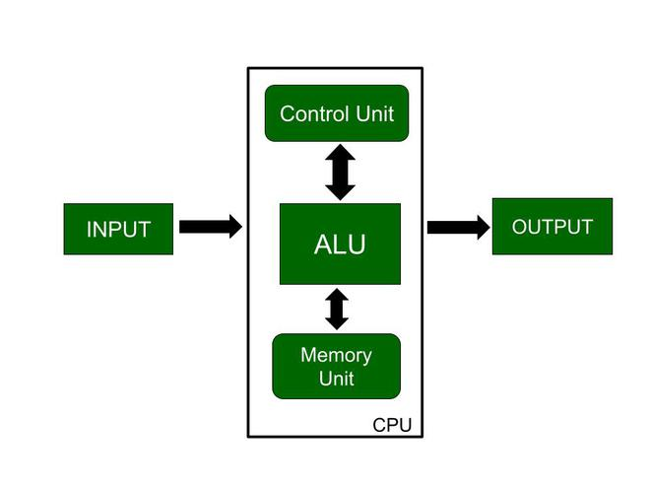

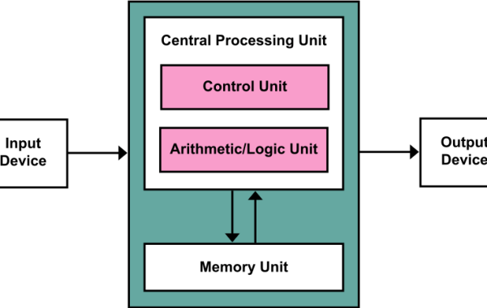

**control unit**

**Control Unit** is the part of the computer’s central processing unit (CPU) the control unit of the CPU must generate the required control signal in the proper sequence. There are two approaches used for generating the control signals in proper sequence as Hardwired Control unit and the Micro-programmed control unit.

A control unit works by receiving input information to which it converts into control signals, which are then sent to the central processor.

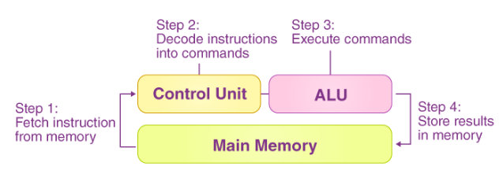

control unit performs are dependent on the type of CPU because the architecture of CPU varies from manufacturer to manufacturer. Examples of devices that require a CU are:

* Control Processing Units(CPUs)
* Graphics Processing Units(GPUs)

**Types of Control Unit –**  
There are two types of control units:

1. Hardwired Control
2. Microprogrammed Control

## **Hardwired Control**

The Hardwired Control organization involves the control logic to be implemented with gates, flip-flops, decoders, and other digital circuits.

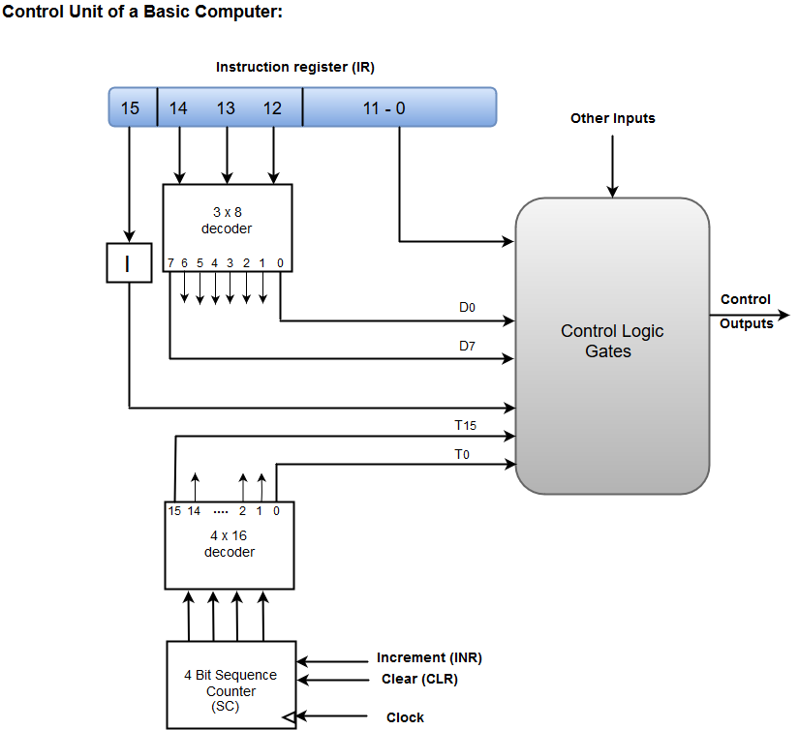

* A Hard-wired Control consists of two decoders, a sequence counter, and a number of logic gates.
* An instruction fetched from the memory unit is placed in the instruction register (IR).
* The component of an instruction register includes; I bit, the operation code, and bits 0 through 11.
* The operation code in bits 12 through 14 are coded with a 3 x 8 decoder.
* The outputs of the decoder are designated by the symbols D0 through D7.
* The operation code at bit 15 is transferred to a flip-flop designated by the symbol I.
* The operation codes from Bits 0 through 11 are applied to the control logic gates.
* The Sequence counter (SC) can count in binary from 0 through 15

## **Micro-programmed Control**

The Microprogrammed Control organization is implemented by using the programming approach.

In Microprogrammed Control, the micro-operations are performed by executing a program consisting of micro-instructions.

The following image shows the block diagram of a Microprogrammed Control organization.

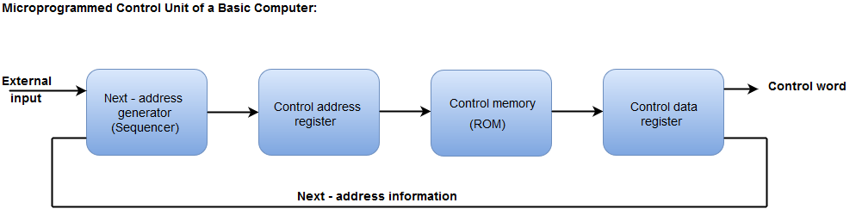

* The Control memory address register specifies the address of the micro-instruction.
* The Control memory is assumed to be a ROM, within which all control information is permanently stored.
* The control register holds the microinstruction fetched from the memory.
* The micro-instruction contains a control word that specifies one or more micro-operations for the data processor.
* While the micro-operations are being executed, the next address is computed in the next address generator circuit and then transferred into the control address register to read the next microinstruction.
* The next address generator is often referred to as a micro-program sequencer, as it determines the address sequence that is read from control memory.

# Hardwired Vs. Micro-programmed Control Unit

In the **hardwired control unit**, the execution of operations is much faster, but the implementation, modification, and decoding are difficult. In contrast, implementing, modifying, decoding **micro-programmed control units** is very easy. The micro-programmed control unit is also able to handle complex instructions. With the help of control signals generated by micro-programmed and hardwired control units, we are able to fetch and execute the instructions.

### **Control Signals**

In order to generate the control signals, both the control signals were basically designed. The functionality of a processor's hardware is operated

* Control signals are used to know what operation is going to be performed.
* It is used to know about the sequence of operations that are performed by the processor.
* It is used to know about the timing at which an operation must be executed and many other types of things.

|  |  |
| --- | --- |
| **Hardwired Control Unit** | **Micro-programmed Control Unit** |
| With the help of a hardware circuit, we can implement the hardwired control unit. In other words, we can say that it is a circuitry approach. | While with the help of programming, we can implement the micro-programmed control unit. |
| The hardwired control unit uses the logic circuit so that it can generate the control signals, which are required for the processor. | The micro-programmed CU uses microinstruction so that it can generate the control signals. Usually, control memory is used to store these microinstructions. |
| In this CU, the control signals are going to be generated in the form of hard wired. That's why it is very difficult to modify the hardwired control unit. | It is very easy to modify the micro-programmed control unit because the modifications are going to be performed only at the instruction level. |
| In the form of logic gates, everything has to be realized in the hardwired control unit. That's why this CU is more costly as compared to the micro-programmed control unit. | The micro-programmed control unit is less costly as compared to the hardwired CU because this control unit only requires the microinstruction to generate the control signals. |
| The complex instructions cannot be handled by a hardwired control unit because when we design a circuit for this instruction, it will become complex. | The micro-programmed control unit is able to handle the complex instructions. |
| Because of the hardware implementation, the hardwired control unit is able to use a limited number of instructions. | The micro-programmed control unit is able to generate control signals for many instructions. |
| The hardwired control unit is used in those types of computers that also use the RISC (Reduced instruction Set Computers). | The micro-programmed control unit is used in those types of computers that also use the CISC (Complex instruction Set Computers). |
| In the hardwired control unit, the hardware is used to generate only the required control signals. That's why this control unit is faster as compared to the micro-programmed control unit. | In this CU, the microinstructions are used to generate the control signals. That's why this CU is slower than the hardwired control unit. |

